3 The Tariff Management Application

3.1 Introduction
The Tariff Management Application (TMA) is a graphical user interface (GUI) developed for the SDP network element. The application can be used on both Windows and Unix platforms and enables the user to connect to an SDP and work with tariff structures and other selection tree structures stored on the SDP. The user can also create and edit selection tree structures off-line.
Multiple windows containing selection trees can be opened at the same time. It is possible to copy and paste tree elements between the different windows.
The Tariff Management Application also has a function for off-line simulation and test of selection trees, which is described in Section 5.
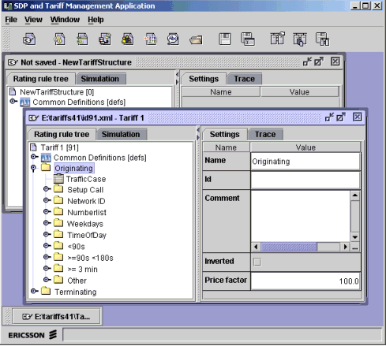
Figure 1 The Tariff Management Application

3.2 Starting the Tariff Management Application
The Tariff Management Application runs on a PC or Unix workstation. Install and launch the application as described in Installation Instruction SDP GUI, Reference [3].
The application can also be launched from within the SDP Management Application (SMA).

3.3 The Login Window
The Login window appears when you try to access any of the SDP servers from the GUI. To connect to the SDP, a login must be performed in this window.
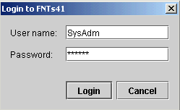
Figure 2 The Login Window
Type user name and password, then press the Login button to log in.
Table 1 describes the fields and buttons in the Login window.

Table 1 GUI Objects in Login Window
Field/Button | Description | Characteristics
User name | The user name to log in as. | This field is case-sensitive.
Password | Password for the user name entered.  An asterisk is displayed for each entered character. | This field is case-sensitive.
Login | Logs in to the SDP.
Cancel | Cancels the login sequence and closes the window.

3.4 The Main Window
This section describes the menus in the main window of the Tariff Management Application. It also describes the Tool Bar and the Status Bar.

3.4.1 File Menu
The File menu is used for creating, accessing, and saving selection tree structures.
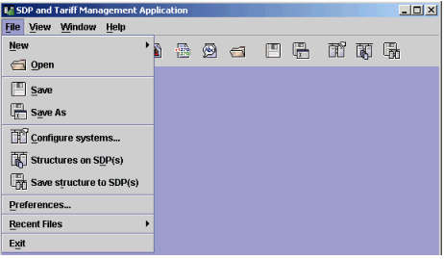
Figure 3 The File Menu
Table 2 describes the menu options in the File menu.

Table 2 Menu Options in File Menu
Menu option | Description
New | The New submenu contains the following options:  Tariff structure  Bonus structure  Accumulator structure  Dedicated account structure  Community structure  Number normalization structure  USSD text message structure⁽¹⁾  Select one of the options to open a window where you can create a new structure of the selected type.  See Section 4.1 for more information on creating new structures. The different types of selection structures are described in Section 6.
Open | Opens a dialog where you can open a structure saved locally on disk.
Save | Saves the current structure to file. If the structure is new, or it was accessed from an SDP, a dialog is opened to save it to a local file.
Save As | Opens a dialog to save the current structure to a new local file.
Configure systems | Opens the Configure Systems window used for configuring SDP connections, see Section 3.5.
Structures on SDP(s) | Opens a window for accessing structures stored on one or several SDPs. The available SDPs must be configured in the Preferences window, see Section 3.6.  It is possible to activate and deactivate the available structures in the SDPs, as well as delete structures that are not active. You can open and work with any of the structures in the tree editor and then save the structure locally or on one or more SDPs.  See Section 4.5 for general information on structures stored on the SDPs. Activating, deactivating, and deleting structures is described in detail in Section 4.5.2.
Save structure to SDP(s) | Opens a dialog for saving the current structure on one or several selected SDPs.  See Section 4.5 for general information on structures stored on the SDPs. Saving a structure on an SDP is described in detail in Section 4.5.4.
Preferences | Opens the Preferences window, which contains global settings for the application. See description in Section 3.6.
Recent Files | Lists the files you have recently opened or saved. To open a listed file, select it from the Recent Files submenu.
Exit | Exits the application.
(1) The SDP can optionally be configured to send the text messages through SMS.

3.4.2 View Menu
The View menu is used for displaying and hiding the Tool Bar and the Status Bar.
Table 3 describes the menu options in the View menu.

Table 3 Menu Options in View Menu
Menu option | Description
Tool bar | Check/uncheck the box to display/hide the Tool Bar.
Status bar | Check/uncheck the box to display/hide the Status Bar.

3.4.3 Window Menu
The Window menu contains a list of all files which are currently open in the editor. Select a file from the list to display this structure in front.

3.4.4 Help Menu
The Help menu contains online help and application information.
Table 4 describes the menu options in the Help menu.

Table 4 Menu Options in Help Menu
Menu option | Description
Contents | Opens the online help system and selects the Table Of Contents tab.
Index | Opens the online help system and selects the Index tab.
Find | Opens the online help system and selects the Search tab.
About SDP and Tariff Management Application | Shows application version and copyright information.

3.4.5 Tool Bar
The Tool Bar gives you quick access to frequently used options in the File menu. It can be displayed or hidden using the View menu.
Figure 4 The Tool Bar
To display the tooltip for any of the icons on the Tool Bar, point at the icon and hold your mouse pointer still.
For more information about the options in the Tool Bar, see the descriptions of the corresponding File menu options in Section 3.4.1.

3.4.6 Status Bar
The Status Bar at the bottom of the main window displays information about the current activity, for example, when opening a file. The Status Bar can be displayed or hidden using the View menu.

3.5 The Configure Systems Window
To open the Configure Systems window, select Configure systems in the File menu. The Configure Systems window is used for adding new configurations as well as editing existing ones. The settings are needed in order to connect to the SDP.

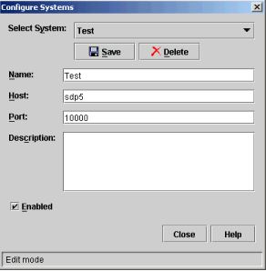
Figure 5 The Configure Systems Window
Note: This window can always be accessed. If changes are made to the configuration of an SDP which is currently connected, the changes will take effect only after disconnecting and reconnecting again to the SDP.
Table 5 describes the fields and buttons in the Configure Systems window.

Table 5 GUI Objects in Configure Systems Window
Field/Button | Description | Characteristics
Select System | Menu for selecting one of the available SDPs or for adding a new SDP.
Save | Saves the current configuration.
Delete | Deletes the configuration for the selected SDP.
Name | The name that is chosen for this connection. It will be used by the GUI in login dialogs and when listing SDPs that are available. | Mandatory field.
Host | The host name or IP address used to identify the SDP in the network. | Mandatory field.
Port | The port number used by the SDP web server to communicate with this application. | Default value: 10000.  Mandatory field.
Description | Description of this SDP connection.
Enabled | This box must be checked to make the host available in the GUI. | Default: Enabled
Close | Closes the window.
Help | Opens the online help system.

3.6 The Preferences Window
It is possible to specify customized settings for the application, such as the work directory for tariff files and the call simulation default values.
Select Preferences in the File menu to open the Preferences window, which contains settings for both SMA and TMA.

3.6.1 General Settings

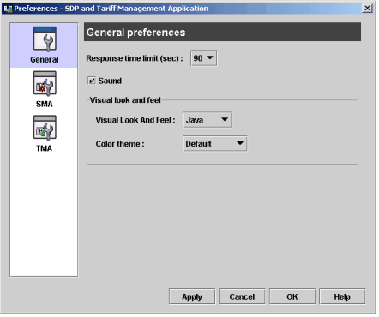
Figure 6 The Preferences Window - General settings
Table 6 describes the General settings in the Preferences window.

Table 6 GUI Objects in Preferences Window, General settings
Field/Button | Description | Characteristics
Response time limit (sec) | Menu for selecting the maximum time that the GUI will wait for a response after a request is sent to the SDP. | Available values: 15, 30, 60, and 90 seconds.  Default: 90 seconds
Sound | Checkbox for sound activation. For example, get a beep sound when alarm. | Default: Checked (sound is activated)
Visual Look And Feel | Menu for selecting a visual look and feel for the GUI.  For example, Platform selected on a PC means that the Windows look and feel will be used. | Available values: Platform and Java.  Default: Java
Color theme | Menu for selecting a color theme for the GUI. | Only applicable for the Java look and feel.
Apply | Applies changes that have been made without closing the window.
Cancel | Closes the window without applying the changes.
OK | Applies changes that have been made, and closes the window.
Help | Opens the online help system.

3.6.2 SMA Settings
These settings are only applicable for the SDP Management Application (SMA). For more information, see SDP User's Guide Service Class Administration, Reference [5].

3.6.3 TMA Settings

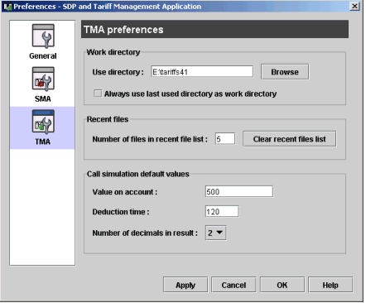
Figure 7 The Preferences Window - TMA settings
Table 7 describes the TMA settings in the Preferences window.

Table 7 GUI Objects in Preferences Window, TMA settings
Field/Button | Description | Characteristics
Work directory | Specify the preferred work directory, or check the box to always use the last directory as work directory.
Recent files | Specify the preferred number of files listed in Recent Files in the File menu. You can also clear this list by pressing Clear recent files list.
Call simulation default values | These parameters are used by the simulation function in this application. Testing of selection trees is described in Section 5.  Specify the preferred default settings for account value, deduction time, and number of decimals in result (range: 0-6).
Apply | Applies changes that have been made without closing the window.
Cancel | Closes the window without applying the changes.
OK | Applies changes that have been made, and closes the window.
Help | Opens the online help system.

3.7 Selection Tree Overview

3.7.1 Introduction
Each selection structure is built in the form of a logical tree with nodes and branches. The nodes and subnodes contain conditions which can be evaluated true or false depending on the call circumstances. When the tree is analyzed, a logic path is determined from the conditions which results in a modifier at the end of a branch. If the tree is a tariff structure, the modifier will usually be a rate to be applied for the call. See the example in Figure 8.

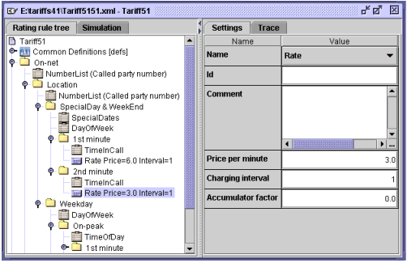
Figure 8 Example of Tariff Structure
The tree is displayed to the left in the tree editor. To the right, the configuration options are shown for the selected node, condition, or modifier in the tree.
The application window has a vertical bar between its left and right frame. Drag the bar to the wanted position to give more space to either of the two frames, or click the arrows at the top of the bar to display only one frame at a time.

3.7.2 Nodes
A node is used to branch a selection tree. It holds a name and groups conditions, other nodes (subnodes) and optionally one modifier. If a node has a modifier, it cannot have any subnodes.
A node is the starting point of a branch and has one or several conditions associated with it. If one of these conditions is true, the underlying structure (modifier or subnodes) is analysed. If a modifier is placed under the node, this completes the branch.
If all conditions associated with a node are false, the analysis will continue with the next node at the same level of nodes.
If none of the branches at a certain level results in a valid modifier, those nodes at a higher level which have not yet been analysed will be gone through.
For each node, it can be specified that the result of the condition evaluation is to be inverted. See Section 7.3.1 for an example of how the condition evaluation is made.
The name of a node is free of choice and will preferably describe what kind of conditions or actions it contains. Examples of node titles can be "09-18", "Monday-Friday", or "Weekends".

3.7.3 Conditions
A condition is a logic decision point and can be evaluated true or false. It is used to check for different call circumstances such as date, time, called number, and type of call. If a condition is true, it will trigger the modifier or the subnode placed below it.
Note: Always specify the condition that is most likely to occur first in the tree and the least likely condition last.
A set of available conditions is specified for each type of selection tree.

3.7.4 Modifiers
The modifier performs selections and calculations for the criteria fulfilled by the logic path given from the conditions.
In a tariff tree, for example, modifiers are used to rate a call or put a special fee to it. They can also be used for barring or specifying calls as free of charge.
A set of available modifiers is specified for each type of selection tree.

3.7.5 Links
It is possible to use links to common definitions of tree elements. This means that nodes, conditions, and modifiers that are used in many places in a selection tree only have to be defined and updated in one place for the entire tree.
The linking function is described in Section 4.3.

3.7.6 Simulator
The selection tree being edited can be simulated in order to test that it works as intended. The simulator is accessed by pressing the Simulation tab. The result of the simulation is displayed in the Trace tab.
The simulator is described in Section 5.

4 Working with Selection Trees

4.1 Creating a Selection Tree
To create a new selection structure, select the File menu, select New and click on the preferred type of structure, for example, Tariff structure.
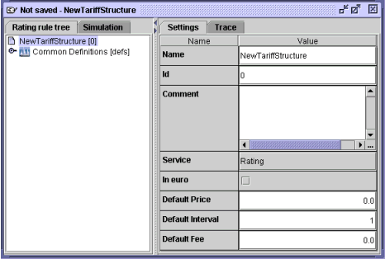
Figure 9 Creating a New Tariff Structure
Specify the required data for the new structure. See the parameter descriptions in Section 7.1.
To save the new structure on disk, you must select Save or Save As from the File menu. To save the structure onto an SDP server, use the menu option Save structure to SDP(s).

4.2 Editing a Selection Tree
This section describes how to display and modify the settings for elements in an opened structure. It also describes how to add and delete nodes, conditions, and modifiers by using the context-sensitive tree menu.
For detailed information about the different selection tree structures in the SDP, see Section 6. See also the parameter descriptions in Section 7.

4.2.1 Editing a Tree Element
The tree structure is displayed in the Rating rule tree tab in the left frame. To display and edit the current settings for a tree element, select the node, condition, modifier, or root element in the tree. The Settings tab can then be used to modify the selected element.
Note: A tooltip is available in the tree and will display information about the current settings when you point at an element in the tree.
Some settings such as the charging interval and the price of rates and fees are always displayed in the tree. If a node uses an inverted condition evaluation, this is displayed after the node name.
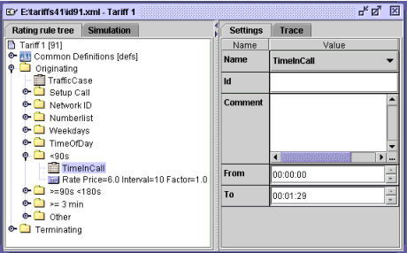
Figure 10 Condition Selected in Tariff Tree
To change the type of a condition or modifier, use the drop-down menu in the Settings tab, see example in Figure 11. The available set of conditions, or modifiers, depends on what kind of structure it is. The tree icon will be labelled according to the chosen type.

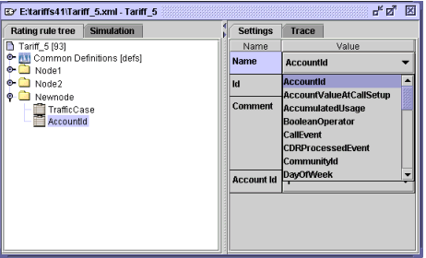
Figure 11 Conditions Drop-Down Menu in Settings Tab

4.2.2 The Tree Menu
A context-sensitive menu is used for the trees in the tree editor, and this section describes the menu options. Right-click on a tree element to open the menu, or select the element and right-click outside the tree.
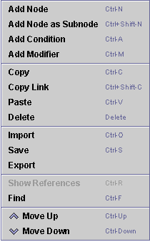
Figure 12 The Tree Menu
When adding or pasting an element, make sure to select the appropriate insertion point. Mark the insertion point by selecting the name of the structure (the root element), a node, or a condition. Right-clicking directly on a tree element also selects the element as insertion point.
Table 8 describes the menu options in the tree menu.

Table 8 Menu Options in Tree Menu
Menu option | Description
Add Node | Adds a new node after the selected node or condition.  To add a node after an already existing node at a certain node level in the tree, select the existing node as insertion point.  To add a node before any other node at the same level, select a condition in the superior node as insertion point. For the highest node level, select the name of the structure as insertion point.  It is possible to insert a subnode in a node although the node has yet no condition connected to it. To do this you must use the Add Node as Subnode menu option.
Add Node as Subnode | Adds a subnode in the selected node.
Add Condition | Adds a new condition in the selected node.  If the node is chosen as insertion point, the condition will be placed first in the node.  If another condition is chosen as insertion point, the new condition is inserted after the selected condition.
Add Modifier | Adds a modifier to the node. Either the node itself or any condition in the node can be used as insertion point.  It is not possible to add a new modifier in a node that already has a modifier or a subnode.
Copy | Copies the selected part of the tree to the copy buffer without removing it from the original location. The copied data can be placed in a different location by using the Paste menu option before you copy something else.
Copy Link | Copies the selected tree object as a link. This option is to be used for items located under Common Definitions. For more information regarding links, see Section 4.3.
Paste | Inserts the previously copied part of the tree at the selected insertion point.  For example:  To paste a modifier (for example, a rate, a fee) into the tree, select either the appropriate node or a condition in that node as insertion point.  To paste a condition after an already existing condition in a node, select the existing condition as insertion point.  To paste a condition before any other condition in a node, select the node as insertion point.  To paste a node after an already existing node at a certain node level in the tree, select the existing node as insertion point.  To paste a node before any other node at the same level, select a condition in the superior node as insertion point. For the highest node level, select the name of the structure as insertion point.  Pasting is not allowed during several circumstances. For example, it is not allowed to paste a modifier into a node that already has a modifier or a subnode.
Delete | Deletes the selected part of the tree with all its content. The deleted data cannot be pasted elsewhere.
Import | Opens a file directory dialog window where a saved structure can be chosen and opened in the current window. The imported structure replaces the contents of the current file.
Save | Saves the current tree.
Export | Opens a file directory dialog window where the current structure can be saved to a new file.
Show References | Opens a window displaying all references to where the currently selected common data is used in the tree. This menu option is useful for viewing which tree elements are linked to each other. For more information regarding links, see Section 4.3.
Find | Opens the Find window (see Section 4.4).
Move Up | Moves the currently selected item one step up. For example, moves the currently selected node before the preceding node at the same level of the tree.
Move Down | Moves the currently selected item one step down. For example, moves the currently selected node after the next node at the same level of the tree.

4.3 Using Links
The linking function in the tree editor makes it possible to define nodes, conditions, and modifiers that can be used in many places in the tree. By using links between common data used in more than one place, the data needs only to be updated in one place for the entire tree.
All tree elements placed under Common Definitions will have icons displaying an anchor symbol. Links made to a common element will contain a target reference, a path, which will be displayed in the tree. An example of a tariff structure containing links and link targets is shown in Figure 13. For a description of icons used for linking, see Table 10.

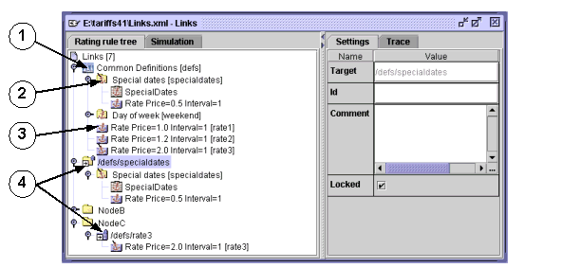
Figure 13 Linking to Elements in Common Definitions

4.3.1 Link Definition
The link definition for a node, condition, or modifier has the following settings (see Figure 13):

Table 9 Link Definition Settings
Field/Button | Description | Characteristics
Target | This field shows the target reference. The target reference indicates where the link origin is located in the rating rule tree.  The path displayed in Target uses the Id's defined in Common Definitions. If an ID is not defined, the Name of the corresponding element is used instead. | Read-only field.
Id | An identification of generic data to be used in the rating rule tree. The text will be shown after the link within angle brackets. The text string must be unique within the tree.  Format: Text field that can contain any keyboard characters.
Comment | This text field can, for example, be used for a description of the link. The comment will be visible in the tooltip when the mouse pointer is placed over the link in the tree.
Locked | Checkbox that needs to be unchecked to enable modification of the rating data in the inserted link.  Options:  Checked - data locked for editing  Unchecked - data can be edited  Note: A change in the rating data will affect all instances where the data is used in the rating rule tree. | Default: Checked (data is locked)

4.3.2 Icons Used for Linking
The special icons used in the tree for links and link targets are described in the following table:

Table 10 Description of Icons used for Linking
Element⁽¹⁾ | Description
1 | Common Definitions.  All rating rule tree entries placed under this node will be anchored entries that can be used in many places in the tree.  Nodes, conditions, and modifiers can be used as definitions.
2 | Used anchored rating rule tree entry.  A used anchored node in Figure 13 has been chosen as an example to illustrate this.  An anchor tilted to the left indicates that the rating rule data is used somewhere in the rating rule tree. In the example, it is used in the section identified by the target reference defs/specialdates.  By selecting a used anchored rating rule tree entry and choosing Show References from the context-sensitive menu, an application window is displayed showing all references to where the data is used in the rating rule tree. It is possible to jump directly to a referenced entry by clicking on it.  If data is changed here it will affect all instances where the data is used in the rating rule tree.
3 | Anchored rating rule tree entry, not used.  An anchored modifier in Figure 13 has been chosen as an example to illustrate this.  An anchor tilted to the right indicates that the rating rule data is not referenced anywhere in the rating rule tree.
4 | Links to Common Definitions.  A locked node link icon and a locked modifier link icon in Figure 13 have been chosen to exemplify this.  An arrow is displayed in the lower left corner, which indicates that this is a link and that the rating rule data is defined elsewhere. In the example, the used data is defined under Common Definitions in the node with Id=specialdates (indicated as 2 in the figure) and in the modifier with Id=rate3. A lock is also displayed in the upper right corner indicating that the data is locked for editing.  Unlocking of data is performed by selecting the link icon and unchecking the Locked checkbox.  Note: If data is changed here it will affect all instances where the data is used in the rating rule tree.
(1) Element numbers according to Figure 13.

4.3.3 Creating and Using a Common Definition
- In an existing rating rule tree, right click on the Common Definitions icon and choose Add Condition from the context-sensitive menu.

A new anchored condition icon is displayed followed by the name of a condition.
- Select the new anchored condition.

The condition configuration options are shown on the right hand side of the application window.
- Enter the condition values for the chosen condition type. Enter a text string in the Id field. The activation of the data is done automatically. The Id text string is displayed after the condition within angle brackets.
- Right click on the anchored condition and choose Copy Link from the context-sensitive menu.
- Place the cursor on the insertion point in the rating rule tree where the condition is to be used.
- Right click and choose Paste from the context-sensitive menu.

A locked condition link icon is displayed followed by the link reference.

4.4 Using the Find Function
The Find function can be used to quickly find items in the rating rule tree. The function is accessed by using the Find option in the context-sensitive tree menu.

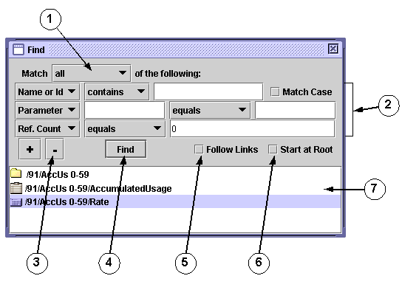
Figure 14 The Find Window
The elements in the Find window are described in the following table:

Table 11 Description of the Find window
Element⁽¹⁾ | Description
1 | Search criteria dropdown menu.  Used for selecting the search logic if more than one search criteria exist. The following options are available:  all  any  All functions as a logical AND which means that all search criteria listed must be fulfilled for the search to be successful.  Any functions as a logical OR which means that any of the listed search criteria can be fulfilled.
2 | Search criteria rows.  For more information, see Section 4.4.1.
3 | Add (+) and Remove (- ) search criteria buttons.  Use these buttons to add a new search criteria row after the last one displayed, or to remove the last one from the list.  There must always be at least one search criteria row.
4 | Find button.  Press this button to execute the search.
5 | Follow Links checkbox.  Check this box to include link elements in the search, for example, elements defined in Common Definitions that are used in the tree. Uncheck the box if links are not to be included in the result.  Note: If Start at Root is unchecked, the search is only performed in the part of the tree specified by the currently selected item, for example, a node.
6 | Start at Root checkbox.  Check this box to start the search at the root of the tree. Uncheck the box to start the search from the selected item in the tree.
7 | Search output.  Displays the result of the search. Click on an item displayed to jump to that location in the tree.
(1) Element numbers according to Figure 14.

4.4.1 Search Criteria Rows
The search criteria rows determine what to search for in the tree. The search input values will vary depending on what is chosen from the first dropdown menu. The following options are available:
Name or Id
Parameter
Ref. Count

Name or Id
Search only for the name or Id of a node, condition, or modifier. Name or Id has the following search input variables:
Name or Id evaluation dropdown menu
The dropdown menu contains the following options:
equals
contains
starts with
ends with
Name or Id input field
Text field where the name or Id of the node, condition, or modifier can be entered. This field will be compared against the values for the Name and Id input fields in the Settings tab.
Match Case
Checkbox used to specify if the case of the name or Id is to be checked or not:
Checked - check case
Unchecked - do not check case

Parameter
Search for a parameter name and value. Parameter has the following search input variables:
Parameter name input field
Text field where the parameter name can be entered. Parts of the parameter name will also work. This field will be compared against all the field names shown in the Settings tab for all nodes, conditions, and modifiers.
Parameter value evaluation dropdown menu
The dropdown menu contains the following options:
equals
not equals
is greater than
is less than
contains
starts with
ends with
Note: The options is greater than and is less than must only be used for numeric parameter values.
Parameter value input field
The parameter value that will be evaluated. Can be either a string or a numeric string. This field will be compared against all the values for the fields shown in the Settings tab for all nodes, conditions, and modifiers.

Ref. Count
Search for nodes, conditions, or modifiers that are referenced a certain number of times using the linking function. Ref. Count has the following search input variables:
Reference count evaluation dropdown menu
The dropdown menu contains the following options:
equals
not equals
is greater than
is less than
Reference count value input field
A numerical value of the number of times a link is used.
Note: If "equals 0" is entered as search input values, all nodes, conditions, and modifiers that are not linked will be listed.

4.5 Accessing and Storing Structures on SDPs

4.5.1 Active and Saved Structures
A tree structure stored on an SDP can be in Activated or Saved state. In the Structures on SDP(s) window, activated and saved structures are located in separate folders. Each structure is displayed with its name and ID.
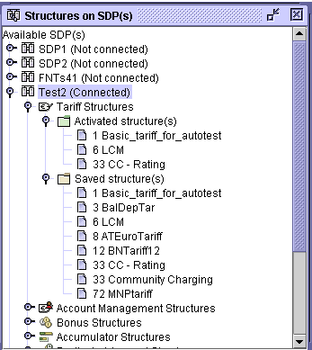
Figure 15 The Structures on SDP(s) Window
An activated structure must always have a unique ID compared with other active structures of the same type.
When a structure is created and saved to an SDP, it is placed in the Saved structure(s) folder in the GUI. Several structures can be saved with the same ID but using different names. A saved structure will not be in effective use by the system until it is activated.
When activating a saved structure, the structure is written to the Activated structure(s) folder while it is still kept in the Saved structure(s) folder. At activation, the structure will overwrite any already existing activated structure with the same ID. There is no link between the files in the different folders. To update a structure that is in use by the system, the structure must be activated again after being edited and saved to Saved structure(s).
Structures in the Activated structure(s) folder can be deactivated, for example, if they are not to be used anymore. Before deactivating, make sure that no existing service class is currently connected to it. When a structure is deactivated, it is deleted from the Activated structure(s) folder. Deactivation of a structure does not affect the contents of Saved structure(s).
For backup purposes, it is recommended always to keep structures in Saved structure(s) that are identical to the currently active structures. If you edit an active structure and save it again to Saved structure(s), give the modified structure a different name. In this way, it will be easy to revert to the previous version after the modified structure is activated. Also, if you deactivate a structure, it can be easily activated again if the structure is available in the Saved structure(s) folder.

4.5.2 Accessing Structures on SDPs
To display selection tree structures stored on the SDPs, select Structures on SDP(s) from the File menu. You must be connected to the SDP to see the structures on it.
Right-clicking on a structure opens the context-sensitive menu. You can also select the structure and right-click in a non-occupied area.
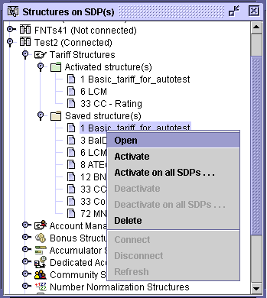
Figure 16 The Context-sensitive Menu in Structures on SDP(s)
The menu options on the context-sensitive menu are described below.

Table 12 Menu Options in Structures on SDP(s)
Menu option | Description
Open | Opens the selected structure in the tree editor.
Activate | Activates the selected structure in the Saved structure(s) list. A copy of the structure is created in the Activated structure(s) list while keeping the saved structure available in Saved structure(s).  It is permitted to activate a saved structure with the same ID as one which is already active. Before overwriting the existing structure in the Activated structure(s) list, you will be prompted to confirm the action.  Note! If a tariff structure is changed and activated with higher tariffs during an ongoing call, there may not be enough money on the account to continue the call and the call will be ended without the normal announcements being played. It is recommended to change tariff structures during low traffic.
Activate on all SDPs | This option makes it possible to activate the selected structure on several SDPs in one operation. A dialog for this operation will appear, see Section 4.5.3.  See Activate for general information about activating a saved structure.
Deactivate | Removes the selected structure from the Activated structure(s) list without copying to Saved structure(s).  Note! Before deactivating a structure, make sure no service class is connected to it.
Deactivate on all SDPs | This option makes it possible to deactivate the selected structure on several SDPs in one operation. A dialog for this operation will appear, see Section 4.5.3.  See Deactivate for general information about deactivating a structure.
Delete | Removes the selected structure from the Saved structure(s) list.
Connect | Opens the Login window (see Section 3.3) so you can connect to the selected SDP.
Disconnect | Disconnects from the selected SDP. You must confirm the logout.
Refresh | Updates the available SDPs, or updates the list of structures on the selected SDP.

4.5.3 Activating and Deactivating a Structure on Multiple SDPs
The dialogs for activating and deactivating a structure on multiple SDPs are opened from the context-sensitive menu in the Structures on SDP(s) window, see Section 4.5.2. The dialogs are similar for both operations and the following description is applicable for both. The examples illustrate the activate operation.
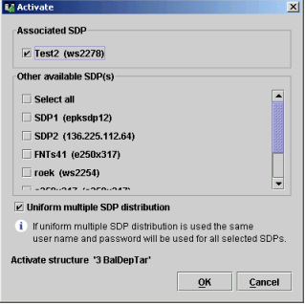
Figure 17 The Activate Window
The available SDPs are displayed in the dialog (host name or IP address shown in parenthesis). The Associated SDP is the SDP on which the structure was accessed.
Select the SDP or SDPs on which the structure is to be activated (or deactivated), then press OK. If Uniform multiple SDP distribution is selected, the same username and password will be used for all the selected SDPs. If Uniform multiple SDP distribution is not selected, you will be prompted to log in on each SDP that you are not already connected to (see Section 3.3).

Table 13 GUI Objects in Activate Window and Deactivate Window
Field/Button | Description | Characteristics
Associated SDP | The SDP on which the structure was selected. The Uniform multiple SDP distribution option will use the username and password of this SDP. | Associated SDP is selected by default.
Other available SDP(s) | Checklist containing SDPs on which the structure can be activated (or deactivated). See also Associated SDP.  The Select all checkbox selects all of the SDPs, but the individual checkboxes can then still be unchecked and checked as preferred.
Uniform multiple SDP distribution | If this option is selected, the same username and password will be used for all selected SDPs during the multiple activation (or deactivation) operation. | Default: Checked
OK | Activates (or deactivates) the structure on the selected SDP or SDPs.  A dialog will be displayed during the progress of the operation, see Section 4.5.3.1.
Cancel | Closes the window without activating (or deactivating).

4.5.3.1 Progress of Activate and Deactivate Operations
While the operation is being performed, the progress is displayed in the Activate or Deactivate dialog.
The login procedure on the SDPs involved in the operation differs depending on if Uniform multiple SDP distribution is used or not, as described in Section 4.5.3.
The following figure shows a dialog after finishing a multiple activation operation. In this example, login on SDP2 failed. It might be that SDP2 is down, but another reason can be that Uniform multiple SDP distribution was used although SDP2 does not have the same username and password as the other servers in the operation.
The Cancel button is used for stopping the execution of the multiple operation during any point of execution.
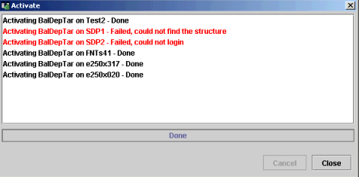
Figure 18 The Activate Dialog

4.5.4 Saving a Structure to SDPs
To be able to store a selection tree structure on an SDP, you must first open the structure and select it in the tree editor.
Select Save structure to SDP(s) from the File menu, and the following dialog for saving the structure will appear:
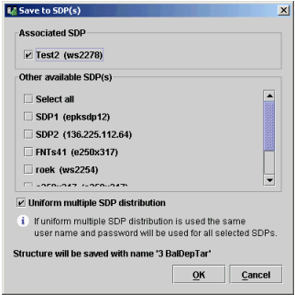
Figure 19 The Save to SDP(s) Window
The available SDPs are displayed in the dialog (host name or IP address shown in parenthesis). If the structure was retrieved from an SDP, this SDP is displayed as Associated SDP.
Select the SDP or SDPs on which the structure is to be stored, then press OK. If Uniform multiple SDP distribution is selected, the same username and password will be used for all the selected SDPs. If Uniform multiple SDP distribution is not selected, you will be prompted to log in on each SDP that you are not already connected to (see Section 3.3).
Different structures in the Saved structure(s) folder can have either the same name or the same ID. If you save a structure with the same name and ID as an already existing structure, you must confirm that the new structure will replace the existing structure.
Note: If an activated structure is edited and then stored in Saved structure(s), the modified structure is not activated automatically.
Table 14 GUI Objects in Save to SDP(s) Window
Field/Button | Description | Characteristics
Associated SDP | If the structure was opened from one of the available SDPs, this SDP is displayed here. The Uniform multiple SDP distribution option will use the username and password of this SDP. | Associated SDP, if any, is selected by default.
Other available SDP(s) | Checklist containing SDPs on which the structure can be stored. See also Associated SDP.  The Select all checkbox selects all of the SDPs, but the individual checkboxes can then still be unchecked and checked as preferred.
Uniform multiple SDP distribution | If this option is selected, the same username and password will be used for all selected SDPs during the multiple saving operation. If you are not connected to any of the SDPs, you will be prompted once for username and password. | Default: Checked
OK | Saves the current structure in the Saved structure(s) folder on the selected SDP or SDPs.  A dialog will be displayed during the progress of the operation, see Section 4.5.4.1.
Cancel | Closes the window without executing the save operation.

4.5.4.1 Progress of Save Operation
While the operation is being performed, the progress is displayed in the Saving dialog.
The login procedure on the SDPs involved in the operation differs depending on if Uniform multiple SDP distribution is used or not, as described in Section 4.5.4.
You will be asked to confirm the replacement of existing structures. If uniform distribution is not used, a simple "Yes" or "No" is requested for each SDP before continuing with the operation on the next SDP. The following figure shows the confirmation window that will appear when Uniform multiple SDP distribution is used. If Yes to all is selected, the multiple saving operation will continue without any further interruption. If Cancel is selected, the execution of the multiple saving operation will stop at this point.
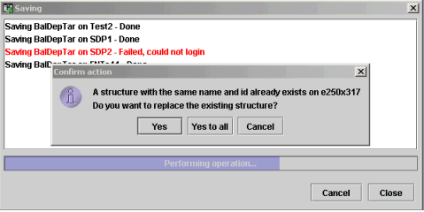
Figure 20 The Saving Dialog

